Interactions among behavioral responses of baleen whales to acoustic stimuli, oceanographic features, and prey availability

A proposal submitted to the Office of Naval Research by

Dr. Elliott Hazen^{1,2}, Dr. Steven Bograd¹, Dr. Ari Friedlaender^{2,3}, and Dr. Doug Nowacek²

¹NOAA Pacific Fisheries Environmental Lab & University of Hawaii JIMAR, 1352 Lighthouse Ave., Pacific Grove, CA 93950 USA
²Nicholas School of the Environment, Duke University Marine Laboratory, 135 Duke Marine Lab Rd. Beaufort, NC 28516 USA
³Southall Environmental Associates, Inc. 911 Center St., Suite B, Santa Cruz, CA 95060

Overview:
The research proposed here intends to provide basic distribution and density information for prey of foraging mysticete cetaceans during behavioral response studies investigating their reactions to human sound exposures. Such basic information into where and why they may be moving and relating to an area is essential in interpreting whether and how such behavior may be affected by the presence of human sounds. This proposal is submitted in close coordination with ongoing and separately funded efforts to conduct the behavioral response studies, as well as an integrated proposal from Southall Environmental Associates. Dr. Elliott Hazen will serve as lead on this project from NOAA-SWFSC-ERD and serve as a key technical component of this research collaboration (see qualifications below).

Project Summary:
From all accounts, the southern California tagging and behavioral response study in 2010 (SOCAL-10) was a resounding success, with a significant amount of both tag deployments and acoustic playback experiments conducted. One of the initial findings was that blue whales that were surface feeding on krill appeared to show less response to playback experiments while the behavior of deep-feeding whales appeared from the initial analysis to be more affected when playbacks occurred. The primary correlate seems to be the specific mode of feeding behavior and prey availability in the water column, perhaps even a threshold effect such that blue whales in an abundance of krill would react differently to acoustic stimuli than blue whales around more discrete krill patches. Analyses of the foraging behavior of large cetaceans have generally focused on either correlations to environmental conditions at a regional scale or observed surface behaviors conducted at a local scale. By measuring fine scale prey distribution, abundance, and behavior our goal is to augment the current research paradigm to better understand how prey influence blue whale foraging behavior and how this knowledge can be linked to observed behavioral responses to various anthropogenic sounds.
We propose an add-on to the SOCAL project in 2011 that would provide density measurements of krill and analysis of oceanographic datasets concurrent to tag deployments. This combined dataset would help us understand ecological needs of blue whales on a fine scale including how density of prey in the water column influences foraging decisions and ultimately may help to mitigate the impacts of navy sonar. Without measurements of the prey field and oceanic conditions at the scale of a tagged whale, it is impossible to separate behavioral response effects from environmental correlates versus experimental sounds. We would run spatial models (e.g. generalized additive mixed models) with whale behavior as a response (e.g. feeding versus traveling, ascent rate) to examine environmental and prey effects on behavior with BRS playback as a categorical covariate (PRN, sonar, none) with an interaction term. These methods would help separate the experimental effects from background behavioral changes. We have conducted similar experimental work to determine the effects of oceanography and prey on other baleen whale species (e.g. Hazen et al. 2009, Friedlaender et al. 2009, Nowacek et al. in review) and have the expertise to successfully conduct similar work as part of the SOCAL experimental design.

Technical Approach and Justification

Marine ecosystems, especially those influenced by intensive human activities, are changing in unprecedented and often unknown ways. In order to maintain sustainable, and healthy environments, integrative knowledge of the structure and function of ecosystem components is a necessity and remains the core of any ecosystem-based management strategy. Indeed, in order to measure and define the impacts of natural and human-induced changes, a baseline of functional relationships and trophic dynamics throughout the ecosystem is paramount. Recently, two major reports (U.S. Commission on Ocean Policy and the Pew Oceans Commission) set forth goals for implementing ‘Ecosystem-Based Approaches to Management’ to gain a better understanding of how marine ecosystems function and adapt to change, and to foster an incremental or adaptive use of knowledge as we gain it (Gulf of Maine Area Program, Census of Marine Life). It is essential to understand population dynamics of multiple species within a system, but how they quantitatively interact with each other and abiotic processes is a common missing link. Our project focusing at fine (<1 km) and seascape (~10 km) scales will provide valuable insight and an analysis framework towards understanding trophic dynamics particularly with regards to anthropogenic influence and global change.

Navy sonar has raised concerns over the impact of anthropogenic sound on marine mammal species (Miller et al., 2000, Parsons et al., 2008). The extent of the area over which anthropogenic noise may cause adverse impacts depends upon the intensity of the sound, how well it propagates underwater, its frequency characteristics and duration. Recent studies have advanced our understanding of how marine mammal species respond to navy sonar particularly on beaked whales (Tyack 2009). Furthermore, little is known how the effects of anthropogenic sound are mitigated by the behavior of affected animals, such as whether feeding or resting predators are more likely to be affected by anthropogenic sound. This project will develop a framework to measure the environmental and prey density around tagged whales to include their influence on impacts from Navy sonar. Understanding behavioral responses requires an understanding of both marine mammal ecology and ambient noise levels within the area of interest.

Off the U.S. West Coast, the California Current System is a highly productive eastern boundary current system that is driven by seasonal upwelling, and supports numerous populations of protected species and economically important fisheries (Croll et al., 2005, Palacios et al., 2006, Wells et al., 2008). This includes marine mammals which are protected under the Marine Mammal Protection Act, such as the gray whale (Eschrichtius robustus), Pacific white-sided dolphin (Lagenorhynchus obliquidens), short-beaked common dolphin (Delphinus delphis) and Risso’s dolphins (Grampus griseus) (Barlow and Forney, 2007). Several species are also listed under the Endangered Species Act, such as the blue whale (Balaenoptera musculus), fin whale (Balaenoptera physalus), humpback whale (Megaptera novaeangliae), sperm whale (Physeter macrocephalus), and southern resident killer whale (Orcinus orca). Blue, fin, and humpback whales feed intensively on krill aggregations in the summer off the coast of California, with the gulf of the Farallones, Monterey Bay, and the Southern California Bight serving as important foraging habitat (Bailey et al. 2010). Fin and humpback whales switch their prey source to focus on migratory fish such as sardines when krill densities decline, blue whales migrate among hotspots to find optimal krill densities.

We will combine foraging data with working models and synoptic data of the area’s physical oceanography to generate novel visualization and statistical approaches to synthesize these data. Our research will (1) provide direct and quantitative estimates of prey consumption and foraging behaviors by various whale species and incorporate these into models to determine interactions between predators and prey; (2) analyze the oceanographic foundation supporting the predator-prey ecology including defining trophic relationships and potential trophic cascades. For example, how do humpback whales affect the distribution, abundance, and behavior of fish prey and how does bottom-up physical forcing affect the food web including cascades to top predator foraging ecology; (3) add significantly to the knowledge of behavior and foraging ecology of baleen whales, and (4) develop novel visualization and analysis tools that can quantify and help construct spatially explicit food web models incorporating both physical and biological data. While ecosystem-based approaches to marine conservation and management are being adapted, little is known about the dynamics of predator-prey interactions in baleen whales and the response to the distribution and behavior of their prey.
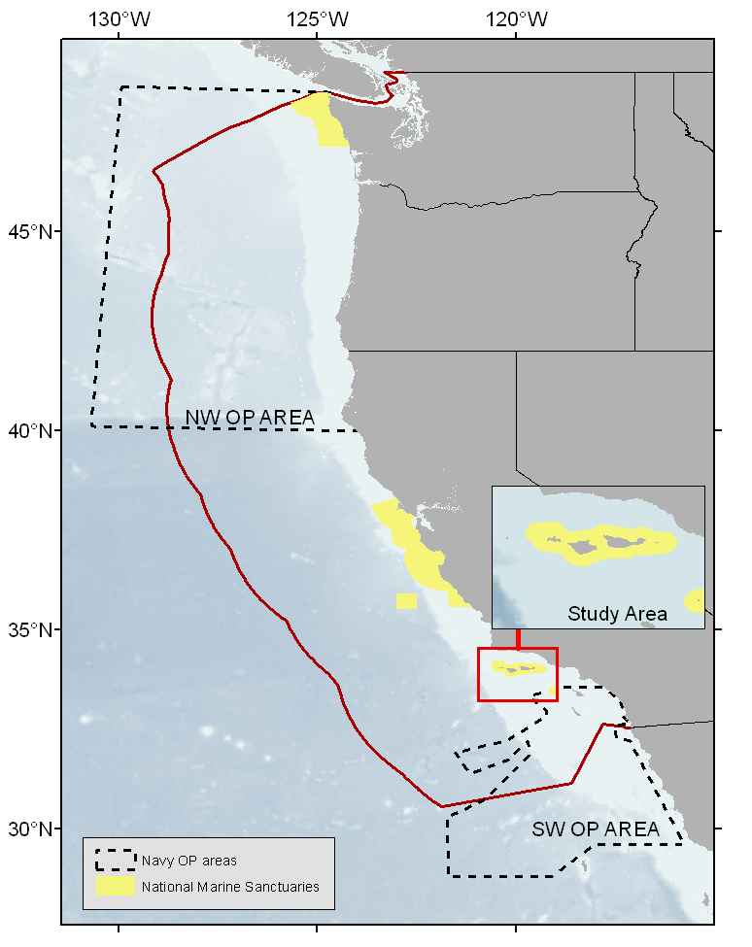Fig 1 – Map of Navy training areas, marine sanctuaries, and focus of proposed study area. The potential study area extends from Morro bay to San Diego.

Physical and biological setting
Southern California Bight (SCB) circulation is forced or stimulated by the California Current, the California Undercurrent, and to a lesser degree by offshore wind flow. Additional circulation is by the Southern California Countercurrent and seasonal eddy currents that form within the SCB. The surface water of the SCB is rich in nutrients, in part because it is largely derived from the California Current which carries biologically productive, well-oxygenated waters southward from the Northern Pacific Ocean. Locally, nutrients are introduced into the surface zone by upwelling currents stimulated by eddies and wind in the Southern California Bight. These nutrients support phytoplankton and large zooplankton ultimately creating a prey base for top predators such as seabirds and baleen whales (Fiedler et al. 1998).

The physical oceanography of the Southern California Bight is dominated by a basin wide counter-clockwise circulation formed at the nexus of the southward California Current (CC) and northward Southern California Countercurrent (SCC). The CC is an eastern boundary current of the North Pacific gyre. It flows equatorward (toward the south) from high to low latitude as a broad, cool, low-salinity, nutrient-rich, and slow- moving surface current. From Oregon south to Point Conception, the CC flows offshore of the continental shelf edge, keeping coastal waters there cool in temperature. South of Point Conception where the Bight cuts sharply to the east, the CC flows roughly 100 miles offshore of southern California. As it travels southward, it interacts with the relatively stationary Bight water. This causes some of the California Current to shear off, forming a poleward-flowing counter current within the Southern California Bight. During winter and spring, northwest winds can steer some of the CC into the northern portion of the SCB, forming vortices in the Santa Barbara Channel. During the winter and spring, equatorward winds accelerate the flow velocity of the CC, causing it to flow more jet-like, with little shearing taking place into the SCB. As a result, the SCC slows to its lowest velocity. During summer and fall, winds relax, reducing the velocity of the CC, allowing more shearing from the CC into the water of the Southern California Bight. This increases the flow velocity of the SCC which in turn promotes eddy development within the Bight.

Finer scale oceanographic processes in the bight are dominated by offshore wind and eddy currents. Strong offshore winds from mainland southern California can drag the surface-ocean water offshore, allowing localized shallow upwelling to occur close to shore. The largest eddy, the Southern California Eddy (SCE), incorporates much of the water of the Southern California Bight in a slow counterclockwise flow (Di Lorenzo 2003). Multiple smaller eddies (~10km) are created by island shear between the mainland and may serve to aggregate prey resources. Eddy circulation within the Bight is strongest during the summer and fall, when equatorward winds relax, the California Current slows, and water shears away from the CC into the Southern California Bight.

Two species of krill, Euphausia pacifica and Thysanoess spinifera dominate the SCB and serve as prey for many commercially important fish (e.g. sardines, rockfish, and salmon) and top predators such as seabirds and rorqual whales (Field and Francis 2006, Field et al. 2006). In the SCB, krill densities are often highest in the summer when increased nutrients and dynamic oceanography serve to support and aggregate prey resources. In the Southern California Bight, Fiedler et al. (1998) found that whales selectively fed on E. pacifica along the 200 m isobath, as well as took advantage of the seasonal swarming of T. spinifera in coastal waters on the shelf. Moreover, blue whales preferentially target adult krill patches, indicating that age and sexual maturity of krill may be an important component for understanding predator-prey interactions in this ecosystem. To date, Croll et al. (2005) have provided the most comprehensive understanding of blue whale foraging relative to oceanography and krill prey, although at scales broader than the individual whale.

This project will serve to address two related and extremely valuable research needs. First, our combined approach of measuring whale foraging behavior in relation to prey, will provide novel and quantitative data that will allow us to better understand the ecology of cetaceans and predator prey relationships along the California coast. Second, this knowledge is imperative to being able to understand and quantify the effects of anthropogenic sound on cetaceans. The fundamental changes being observed and measured in the BRS study relate to cetacean feeding behavior. Thus understanding how differences in prey (distribution, abundance, and behavior) affects how and when whales forage is vital to determining the types of sound that, on their own, lead to behavioral changes in cetaceans.

Statement of Work
- Background

Research to Date
Since 2006 (and continuing through 2011), our team has worked to understand humpback whale foraging on sand lance (Ammodytes spp.) in the Gulf of Maine and on krill (Euphausia superba) in the Western Antarctic Peninsula. We have been able to investigate individual humpback whale movement patterns and foraging strategies using novel tagging, fisheries acoustic, and analytical technologies. The results of this research to date are yielding unprecedented insights into the feeding behaviors and predator-prey ecology of humpback whales.

Hazen et al. (2009) conducted a geospatial analysis of the roles several environmental features (bathymetry, slope, bottom type and tidal stage) play in foraging patterns of humpback whales at the regional, seascape (~10 km), and local scale (< 1km). Whale movement and behavior in three dimensions was related to synoptic prey data collection and simultaneous surface measurements of temperature and relative fluorometry (phytoplankton density). At the, seascape scale researchers found (1) a negative relationship exists between relative fluorometry and sand-lance prey density; (2) a positive relationship between predator and prey densities co-occurring over bottom types of sand and mud near high-slope edges; (3) a cyclical relationship with tidal height (a proxy for upwelling as well as a potential zooplankton aggregator); and (4) an observed temporal lag between peak prey and predator densities. These seascape scale findings support a trophic cascade model of regional predator-prey patterns. At the local behavioral observation scale: (1) time of day was the most important factor in explaining feeding versus non-feeding behavior; and (2) surface feeding occurred more often around larger, vertically oriented schools. Vertically distributed schools of sand lance appeared to be preferentially exploited by bubble feeding techniques. Studies that determine threshold densities of prey required for whale foraging, the effects of predation on prey school size and behavior, and examine the effects of oceanographic conditions on predator-prey interactions are essential for developing ecosystem-based approaches to resource management in marine systems.

Friedlaender et al (2009) used similar tag and prey data to investigate diel changes in humpback whale feeding behavior in response to sand lance behavior and distribution. They note that the foraging strategies of a predator are influenced by its own constraints as well as the behavior of its prey. Humpback whales have adapted unique feeding styles to take advantage of various prey species throughout their range, including sand lance. However, ecological analyses of these behaviors have not been completed and current descriptions have emphasized only surface feeding behaviors. Surface feeding behaviors were heavily biased towards daylight hours, when prey were most abundant in the upper portion of the water column, while bottom feeding occurred largely at night, coincident with the period when sand lance descend into the substrate. These data indicate that individual whales can and do perform both surface and bottom feeding behaviors, switching from one to the other in relation to changing light and prey conditions.

In the Southern California Bight, Friedlaender et al. successfully deployed Dtags on 23 blue whales and 7 fin whales in 2010 (humpback whales were not tagged in 2010 due to permit requirements, but may be added and targeted in 2011). Initial results indicate that blue whale response to anthropogenic sound was in someway mitigated by foraging behavior: deep diving blue whales apparently aborted feeding while surface feeding whales were less affected by anthropogenic sound (Friedlaender, Southall personal communication). Understanding prey densities and the oceanographic context will help us better understand the baseline behavior of blue whales in addition to their reaction to sonar playbacks. We will adapt previously successful prey mapping techniques from the aforementioned projects to blue whales in the bight, as our previous success should translate well to this ecosystem.

- Scope/Objective
Research Goals and Hypotheses

To elucidate the ecological relationships amongst blue whales, their prey, and the influences of oceanographic processes, we have several specific research goals and targeted hypotheses to direct our research program. We will use an individual-based approach concurrently with a seascape scale analysis at the community level to understand the foraging ecology and behavior of various mysticete cetaceans. These predator data integrated with hydro-acoustic sampling methods for prey distribution and abundance, and synoptic measurements of physical environmental features will help elucidate the baseline trophic relationships between predators and prey and how that might affect acoustic playbacks. Our research goals are: 1) to obtain direct and quantitative estimates of prey density and distribution and area-use patterns by individual whales to understand their ecological impact; 2) to characterize the trophic dynamics of how whales affect or are affected by the distribution, abundance, and behavior of their prey; 3) to add to the paucity of knowledge regarding the foraging ecology of baleen whales specifically across multiple spatial scales; Our hypotheses are: 1) whale consumption rates and foraging behaviors are related to prey distribution and biomass at the scale of the individual whale (i.e. 10s to 1000s of meters); 2) oceanographic processes (e.g. increased phytoplankton) and physical features (e.g. 200m isobaths) in the SCB enhance prey availability, leading to localized habitat use patterns for foraging whales. 3) foraging behavior (e.g. surface lunges, deep dives) will be directly related to prey density. Ultimately, this information can be used to test whether at high prey densities, foraging whales are less affected by anthropogenic playbacks than at lower prey densities.

Hypothesis #1 will be directly tested with our methods and has direct implications for the ecological processes currently under study in our and to inform ecosystem-based management in the SCB. Testing hypothesis #2 will enable us to investigate the effect that a single or multiple whales have on prey distribution and abundance, including over multiple spatio-temporal scales using our geo-spatial modeling expertise. Hypotheses #3 will be addressed using prey field measurements, concurrent and synoptic sampling of physical features, and analysis of behavior from tag data. By analyzing oceanography, prey density, and behavior patterns before, during and after playback experiments our results could be used to better understand how foraging whales are affected by navy sonar. With a greater understanding of whale behavior, we can incorporate this knowledge into management strategies for blue whales in the California current and provide a much needed update to previous studies by Fiedler (1998) and Croll (2005).

Sampling Methodology
In August of 2011 (and 2012 under Option 1), we will measure fine-scale prey density and distribution and individual predator behavior using the existing research platform (R/V Truth). As animals perceive and react to their environment at a range of scales, there is no single scale correct for studying ecological relationships (Levin 1992), therefore we are trying to resolve prey and predator distribution at similar scales. By analyzing prey and predator at fine scales, we can test for and understand (1) the ecological decisions made by individual whales when foraging, and how the broader environmental features affect blue whales
in the SCB.
Prey sampling - Prey distribution and abundance will be continuously measured using 38 and 120 kHz SIMRAD EK60 echosounders at fine scales (<10 km). Acoustic data collected in the absence of sighted whales are treated as a control measure of ambient prey density. Fine scale sampling methods are dependent on the behavior of the tagged whale so an iterative approach to sampling prey is employed. If the tagged whale is traveling (>1km per hour displacement), a zig-zag design will used to survey prey distributions passed over by the whale by sampling in its wake (1.4km long transects). If the tagged whale is surface feeding (defined as observing the animal with its mouth gaped or bubbles located where the animal surfaced), a clover leaf sampling design allows the measurement of prey abundance and distribution, with the center of the sampling box moving with the whale (Fig 2). The sampling design around non-feeding and non-traveling (i.e. resting) individuals is identical, with a cloverleaf used to examine the prey distribution in the absence of feeding. When measuring prey relative to surfacing events, transects will be designed to pass within 500 meters of the tagged whale. Correlations between whale behavior, prey data, and environmental data, will only be considered within a 500m radius of a whale surfacing. As a result, our design will allow us to quantify the distribution, abundance and dimensions of prey patches in close proximity to foraging and non-foraging whales. We will compare the two frequencies of acoustic data to differentiate krill from larger fish targets as krill have greater backscatter at 120kHz than 38kHz.
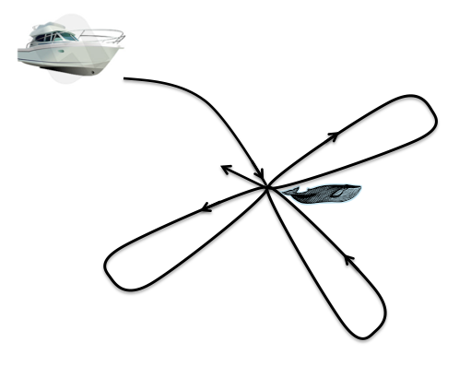
Fig 2. Clover leaf sampling design around tagged whale. Each leaf is 1km from the center.

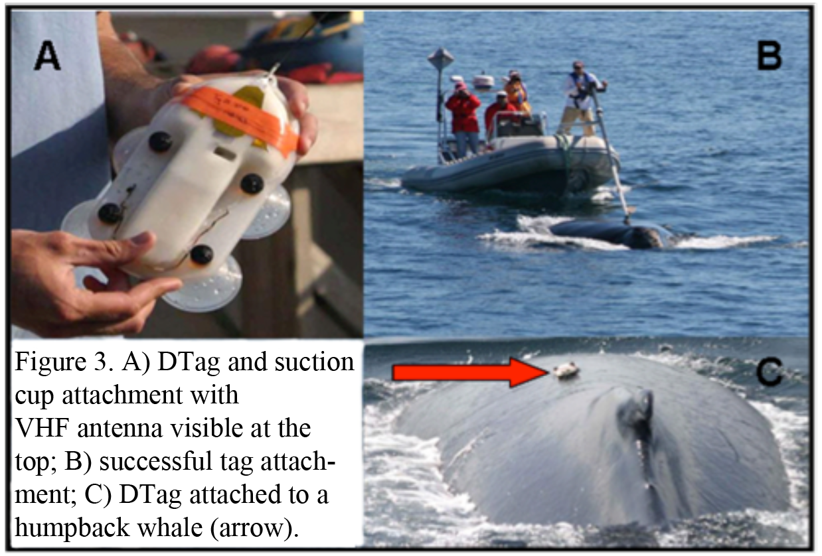
Whale data - Whale behavior (e.g., feeding/non-feeding) is inferred from the tag record in combination with near continuous daytime focal surface observations. Tag attachment will be accomplished using a rigid-hulled inflatable boat (RHIB) equipped with a 14 meter, bow mounted, cantilevered carbon-fiber pole. The Dtag is a small, lightweight, pressure tolerant tag capable of recording data for up to ~20 hours and attached to the whale non-invasively via suction cups (Johnson and Tyack 2003, Figure 3). The Dtag measures the acceleration in the animal’s pitch, roll, and heading, as well as depth, and water temperature at 50 Hz. Data from the pitch record allows for analysis of fluke stroke rates and relative stroke amplitudes and combined with behavioral observation allows the identification of surface feeding bouts and quantification of their duration and maximum depth (e.g. Tyack et al. 2007, Friedlaender et al. 2009). All sensor data are stored in flash memory on the tag and are downloaded via an infrared connection to a computer for analysis. The tag has a VHF antenna which transmits when at the surface, allowing us to follow the whale when it is either out of visual range or during nighttime. Additionally, the tag has 2 hydrophones which continuously record any noises the animal either makes or encounters (Johnson and Tyack 2003).

Focal follows of tagged animals and associates occurred continuously during daylight hours using techniques described in Whitehead (1983) and Weinrich and Kuhlberg (1991) from the tag boat. In 2010, whenever possible, the tagged animal’s position was recorded by marking a GPS position at the location (foot-print) where a whale dove. In 2011 we will augment this by collecting high-resolution range and bearing measurements using a laser range-finder (Leica Vector IV), to georeference the surfacing locations of the tagged whale more frequently. Similar to previous studies using non-linear generalized additive models (Friedlaender et al. 2006), we will quantify the effects of remotely sensed environmental features and prey abundance on the distribution and abundance of whales at the seascape scale (see Figure 1). This approach will provide estimates of (1) prey and environment in the SCB and (2) the functional relationships between prey density and school size and predator aggregation size.

Analysis Methodology
Prey sampling - Acoustic data will be processed using Myriax Echoview software. This software will allow marking of individual schools for echo-integration and export using the school detection algorithm. We can use the mean volume backscatter strength (MVBS, a measure of acoustic density) from each school as well as shape characteristics (height, length, depth, area) to examine patch dynamics at both fine and seascape scales (e.g. Hazen et al. 2008). To examine overall water column biomass, acoustic backscatter will also be vertically integrated into the nautical area scattering coefficient (s_{A}; m²/nmi²), a relative measure of biomass. These measurements can be subsequently gridded into 50 m² horizontal cells by 1 m vertical cells and integrated with a -90 dB threshold to examine smaller prey aggregations. All exported acoustic biomass data including georeferenced 2-dimensional school parameters (MVBS, length, mean height, mean depth), integrated cell biomass (sA, density per 50m), and bottom depth will be imported into ESRI’s ArcGIS 10 for spatial analysis.

Whale Data - We can combine the pitch, roll, heading, and depth data from the Dtag with the whale’s surfacing locations to generate a georeferenced “pseudo-track” of each animal’s movements. The pseudo-track can then be incorporated into TrackPlot, a customized visualization software package which allows for examination of temporally sequenced behaviors as spatial patterns (Ware et al. 2006). The program creates a continuous 3D ribbon indicating the direction of travel, body orientation (pitch and roll), depth, and kinematic movements like fluke strokes. To visualize certain behaviors, like rolling, the ribbon incorporates sensor data and twists around the along-track heading highlighting characteristics of interest (Figure 4, Ware et al. 2006).

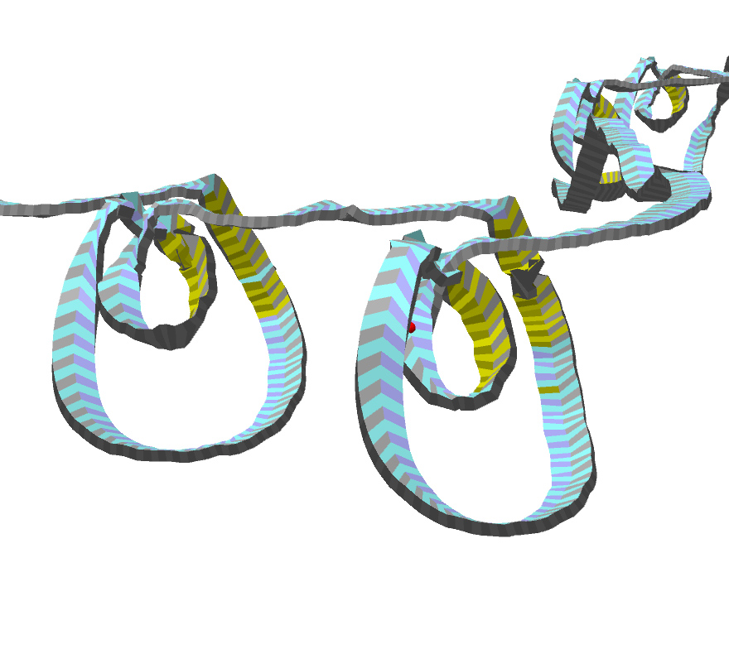 | 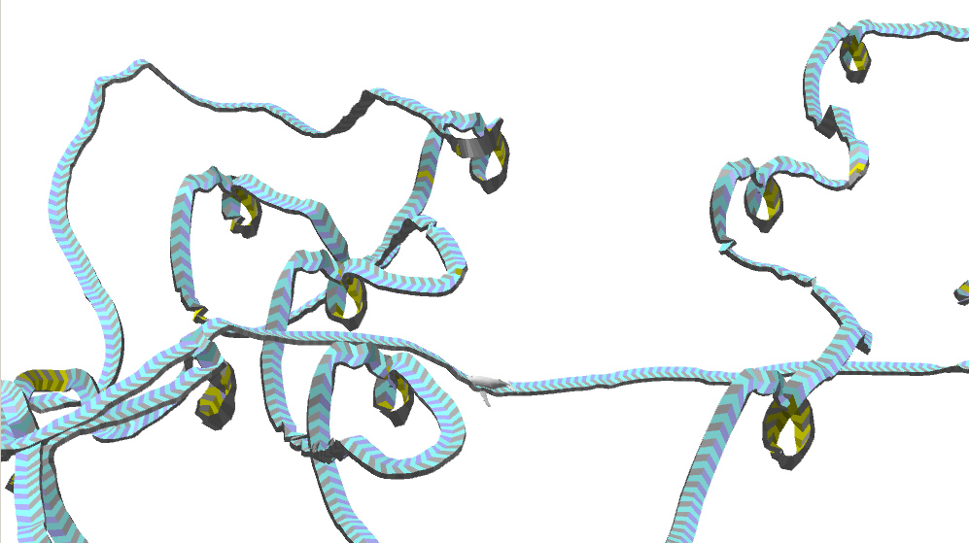 | 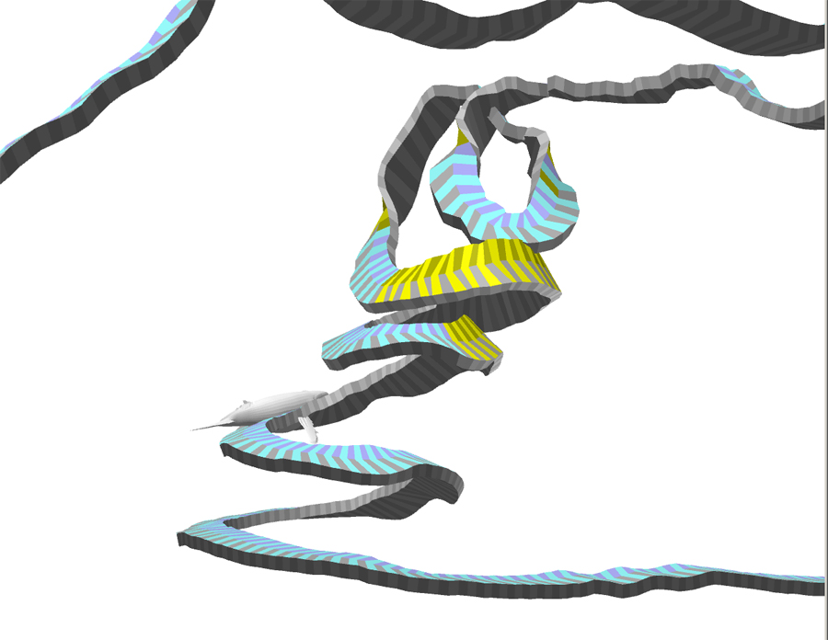 | 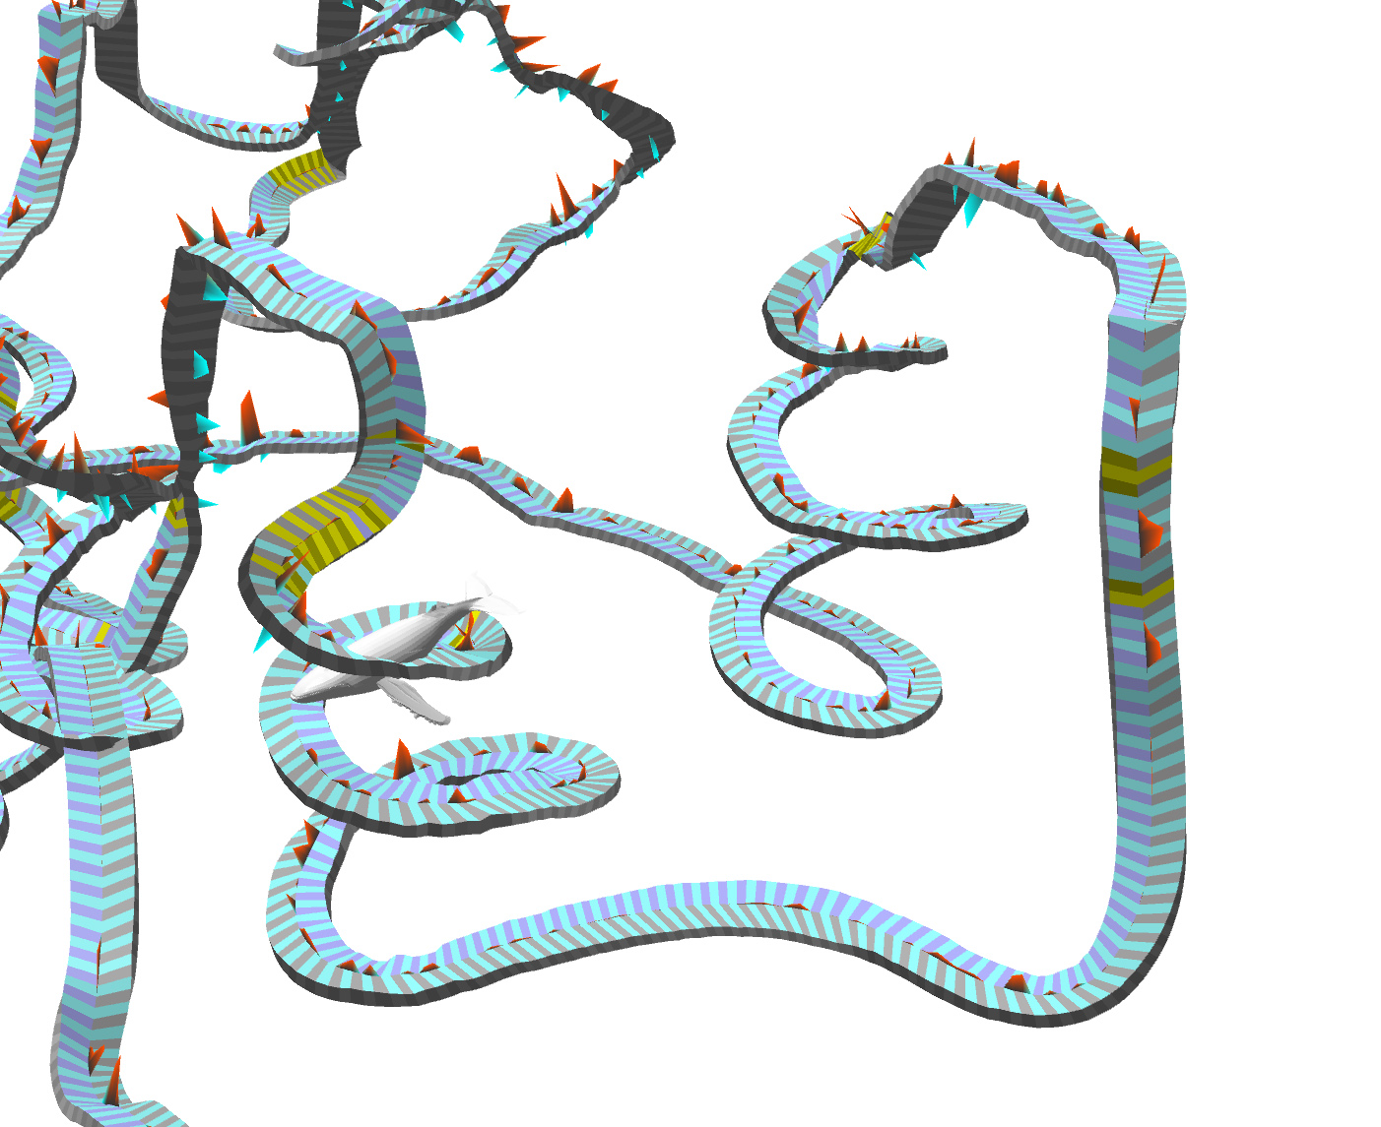
Figure 4 - Classes of surface feeding revealed using TrackPlot. Yellow represents >45º roll.

We can then code every surfacing from each tagged whale as a surface feeding, mid-water feeding, bottom feeding, or non-feeding surfacing event, based partly on the behavioral observations during focal follows. Using previously calibrated methods (Hazen et al. 2009, Friedlaender et al. 2009), time-linked surfacing observations from the behavioral data and TrackPlot ribbons can be used to define underwater movement patterns that result in a feeding event. We have used a blind comparison from a subset of data to code surface feeding events in TrackPlot which were validated against behavioral data and found agreement 97% of the time (n = 100 events). The mean depth of feeding events and total dive duration per feeding event will be analyzed using TrackPlot and compared to prey distribution. Surface feeding and non-feeding surface events can then imported into ArcGIS for spatially-explicit analysis.

Data sampling and statistics - For prey data, we can use generalized additive models (GAMs) to examine the non-linear relationship between prey density and environmental variables using a Gaussian distribution. A generalized linear model (GLM) can examine the linear effects of each environmental variable on prey density. To examine thresholds in predator behavior, a Classification and Regression Tree (CART; Redfern et al. 2006) will be run with whale surface behavior as the response variable. Optimal recursive partitioning combined with a cross-validation using explained deviance ensured that only the most significant breaks are included in the final model. GAMs can then be used to examine the non-linear relationship between CART selected variables and whale foraging behavior and to test for significant effects. We will also include whale behavior as a response (e.g. feeding versus traveling, ascent rate) variable and BRS playback as a categorical covariate (PRN, sonar, none) to examine environmental and prey effects and to help separate the experimental effects from background behavioral changes.

Because whales forage at multiple scales (e.g. travel, search, feeding), having multiple analysis scales can help to resolve these processes. Our fine scale approach can examine feeding events and prey density dependence for an individual whale, but we need the seascape scale analysis relative to remotely sensed data to tease apart the broader scales of foraging behavior such as travel and search. With multiple years of data (option 1) we can look at annual variability in prey patch metrics, variability of an individual whale’s foraging strategy if tagged twice, as well as individual variability among whales. TrackPlot will allows us to quantify the fine scale changes in pitch yaw and roll that characterize differential feeding events for all tagged whales as well as for each individual whale; this is an important step towards understanding foraging behaviors of a top predator in both an evolutionary and conservation framework.

- Requirements
The contractor will measure fine scale prey densities using SIMRAD echosounders in and around tagged rorqual whales (fin, blue, and/or humpback, SOW 3.1). The contractor will (3.2) analyze the collected data to create 3d prey fields for use in assessing behavioral responses. The contractor shall (3.3) analyze tag data to identify foraging lunges and other behavioral states. Finally, the contractor will (3.4) use models to analyze foraging behavior relative to measurements of prey and remotely-sensed measurements of the environment (e.g. temperature, sea surface height, chlorophyll-a). Under option 1, contractors will collect a second year of data and perform the identical analyses (3.5-3.8). In addition, under option 1 the contractors shall work to publish two papers on 3.9 whale behaviors from tag data and 3.10 whale foraging models.

- Deliverables
Quarterly fiscal reports will be delivered to the agency to ensure spending is on target. The end of year report in FY11 will outline the data collected (hours of acoustic data, number of tags deployed, 3.1) and discuss progress towards completion of the task. The end of year report in FY12 will include analysis of tag and acoustic data to be used to understand how prey might affect behavioral responses to acoustic playbacks (3.2-3.4). Under option 1, the end of year report in FY12 will also include the second year of data collected (3.5). The end of award for FY13 will include the updated analyses of tag and acoustic data (3.6-3.8) and will also include draft manuscripts from the outcome of the research and modeling efforts (3.9,3.10).

5.0 Project Schedule and Milestones: Plan of Action & Milestones

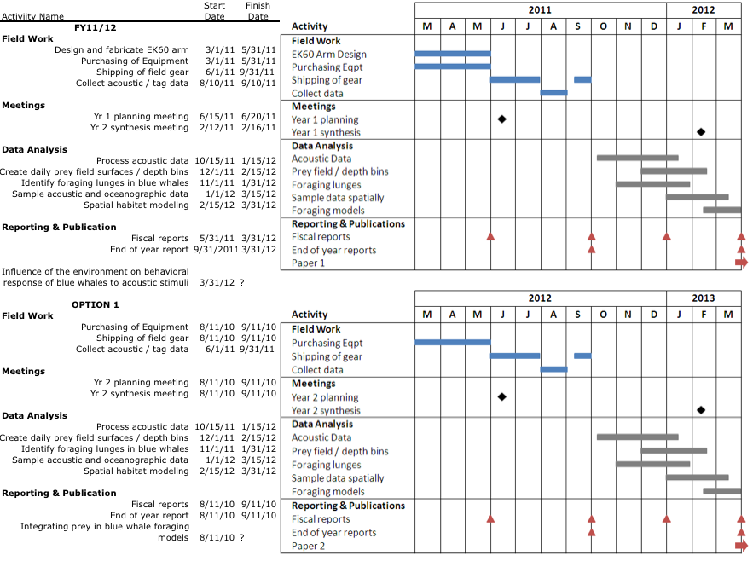
6.0 Management Approach

The work outlined in this proposal is a collaboration between the NOAA SWFSC Pacific Fisheries Environmental Lab, Duke University, and Southall Environmental Associates. The goals of this proposed research were borne from mutual interests and the personnel were organized to maximize their respective strengths towards successfully achieving the objectives of this proposal. We are confident that we will collect and have access to a unique set of data not available to any other set of researchers (both academic and governmental). The opportunity presented by ongoing SOCAL efforts provides a necessary forum and support for comparing, contrasting, and modeling the role of top predators in marine ecosystems. We feel this is a logical and well-founded extension of previous and ongoing research .

Dr. Hazen (NOAA SWFSC Pacific Fisheries Environmental Lab) will be in charge of managing the proposed research and coordinating data integration and analysis among the collaborators. In addition, he will lead acoustic data collection, analyses and will be involved with developing and parameterizing spatial models of predator and prey. Hazen has successfully devised quantitative means for determining how the foraging behavior of top predators can be influenced by changes in the distribution and abundance of their prey, and will further develop these methods through the proposed research. Likewise, he will be integral in synthesizing how prey and whales are influenced by the physical environment in the SCB ecosystem. Dr. Hazen’s time on this project will be supported under a separate proposal.

Dr. Friedlaender (SEA, Inc.) will bring needed expertise in spatial ecology of predators and prey and will continue his innovative work on cetacean foraging ecology from tag data. He will lead analysis of all of the tag data from FY11 (and FY12 under option 1) to categorize rorqual behavior (e.g. foraging, resting). Furthermore, Friedlaender will identify specific lunge events and will help incorporate these into foraging models of the tagged whales. This proposal includes support for Dr. Friedlaender in this regard, as well as the purchase of project equipment through SEA and a small amount of support for coordination of equipment acquisition and project planning.

Dr. Nowacek (Duke University) will provide acoustic and top predator expertise and will loan his acoustic gear to the project. Dr. Nowacek will provide 38 and 120 kHz SIMRAD EK60s and an Echoview dongle for analysis of acoustic data. As Nowacek has led similar projects in Antarctica, his experience with leadership will be contributed to the project.

Dr. Bograd (NOAA SWFSC Pacific Fisheries Environmental Lab) will serve as primary liaison for the SWFSC and supervisor for JIMAR researcher Dr. Hazen. Bograd will aid in both remotely sensed oceanographic data processing and analysis. Dr. Bograd’s experience with remotely sensed data and oceanography is well demonstrated and will provide extensive expertise to the SCB.
Personnel Qualifications
STEVEN J. BOGRAD

A. Professional Preparation
1985 B.S. (Physics), B.S. (Atmospheric Sciences), University of Arizona.
1989 M.S. (Atmospheric Sciences), University of Washington.
1998 Ph.D.(Oceanography), University of British Columbia.
1998-2000 Postdoctoral Research Associate, Scripps Institution of Oceanography.

B. Appointments
2007-present Research Associate, Integrative Oceanography Division, Scripps Institution of Oceanography
2005-present Supervisory Research Oceanographer, NOAA Southwest Fisheries Science Center
2001-2005 Research Oceanographer, NOAA Southwest Fisheries Science Center
2000-2001 Academic Administrator (CalCOFI coordinator), Scripps Institution of Oceanography
1998-2001 Postdoctoral Researcher, Scripps Institution of Oceanography
1993-1998 Research Assistant, University of British Columbia
1989-1993 Research Scientist, JISAO/University of Washington

C. Publications
- Publications related to proposed project
Bograd, S.J., B.A. Block, D.P. Costa, and B.J. Godley (2010) Biologging technologies: new tools for conservation. Endangered Species Research, 10, 1-7.
Bograd, S.J., I. Schroeder, N. Sarkar, X. Qiu, W.J. Sydeman and F.B. Schwing (2009) The phenology of coastal upwelling in the California Current. Geophysical Research Letters, 36, L01602, doi:10.1029/2008GL035933.
Sydeman, W.J., and S.J. Bograd (2009) Marine ecosystems, climate and phenology: impacts on top predators: Introduction. Marine Ecology Progress Series, 393, 185-188.
Shillinger, G.L., D.M. Palacios, H.R. Bailey, S.J. Bograd, A. Swithenbank, P. Gaspar, B. Wallace, J.R. Spotila, F.V. Paladino, R. Piedra, S.A. Eckert, and B.A. Block (2008) Persistent leatherback turtle migrations present opportunities for conservation. PLoS Biology, 6(7), e171, doi:10.1371/journal.pbio.0060171.
Wells, B.K., J.C. Field, J.A. Thayer, C.B. Grimes, S.J. Bograd, W.J. Sydeman, F.B. Schwing, and R. Hewitt (2008) Untangling the relationship between climate, prey, and top predators in an ocean ecosystem. Marine Ecology Progress Series, 364, 15-29.

- Other significant publications
Bailey, H., B. Mate, L. Irvine, D.M. Palacios, S.J. Bograd, and D.P. Costa (2009) Behavioural estimation of blue whale movements in the Northeast Pacific from state-space model analysis of satellite tracks. Endangered Species Research, 10, 93-106.
Kappes, M., S.A. Shaffer, Y. Tremblay, D.G. Foley, D.M. Palacios, P.W Robinson, S.J. Bograd, and D.P. Costa (2010) Hawaiian albatrosses track interannual variability of marine habitats in the North Pacific. Progress in Oceanography, 86, 246-260.
Bograd, S.J., C.G. Castro, E. Di Lorenzo, D.M. Palacios, H. Bailey, W. Gilly, and F.P. Chavez (2008) Oxygen declines and the shoaling of the hypoxic boundary in the California Current. Geophysical Research Letters, 35, L12607, doi:10.1029/2008GL034185.
Di Lorenzo, E., N. Schneider, K.M. Cobb, P.J. Franks, K. Chhak, A.J. Miller, J.C. McWilliams, S.J. Bograd, H. Arango, E. Curchister, T.M. Powell, and P. Riviere (2008) North Pacific Gyre Oscillation links ocean climate and ecosystem change. Geophysical Research Letters, doi:10.1029/2007GL032838.
Bograd, S.J., and R.J. Lynn (2003) Long-term variability in the southern California Current System. Deep-Sea Research II, 50(14-16), 2355-2370.

D. Synergistic Activities
- Principal Investigator, Census of Marine Life – Tagging of Pacific Pelagics (TOPP), 2002-present.
- U.S. Delegate, North Pacific Marine Science Organization (PICES), Physical Oceanography and Climate Committee, 2004-present.
- Associate Editor, Fisheries Oceanography; Academic Editor, PloS ONE
- Guest Editor, special volumes of Deep-Sea Research II (2003), Progress in Oceanography (2007), Endangered Species Research (2010).
- Research Associate, California Current Ecosystem Long-Term Ecological Research, 2004-present.

E. Collaborators and Other Affiliations
- Collaborators and co-editors
B. Block (Stanford), C. Castro (CSIC), F. Chavez (MBARI), D. Checkley (SIO), T. Chereskin (SIO), C. Collins (NPS), D. Costa (UCSC), E. DiLorenzo (GaTech), R. Goericke (SIO), E. Howell (NMFS), A. Huyer (OSU), A. Mantyla (SIO), S. McClatchie (NMFS), J. McGowan (SIO), A. Miller (SIO), A. Peña (IOS), S. Shaffer (UCSC), T. Strub (OSU), W. Sydeman (PRBO), A. Thomas (UMaine), Y. Tremblay (UCSC), E. Venrick (SIO)
- Graduate advisors and postdoctoral sponsors
M.S. Adviser: Bob Houze (University of Washington). Committee members: J. Holton (UW), C. Mass (UW)
PhD Adviser: Paul LeBlond (University of British Columbia). Committee members: S. Pond (UBC), P. Stabeno (NOAA), R. Thomson (IOS)
Postdoctoral Advisers: Teresa Chereskin (SIO), Mike Mullin (SIO)
- Thesis-advisor and postgraduate-scholar sponsor
Graduate Students (6): George Shillinger and Chris Perle (Stanford), Dana Wingfield and Sara Maxwell (UC-Santa Cruz), Jennifer Ayers and Erin LaBrecque (Duke)
Postdoctoral Scholars (National Research Council) (5): Daniel Palacios, Helen Bailey, Nandita Sarkar, Isaac Schroeder, Elliott Hazen (all at NOAA)

ELLIOTT HAZEN

A. Professional Preparation
2000 B.A. (Biology), Duke University.
2003 M.S. (Fisheries Science), University of Washington.
2008 Ph.D. (Ecology), Duke University.

B. Appointments
2008-2009: Postdoctoral Research Associate, Duke University
2009-2010: National Research Council Postdoctoral Research Associate NOAA Environmental Research Division, Pacific Grove, California, U.S.A.
2010-present: JIMAR/PFEL Research Oceanographer, Pacific Grove, California, U.S.A.

C. Publications
1. Publications related to proposed project
Friedlaender A.S., E.L. Hazen, D.P. Nowacek, C. Ware, M. Weinrich, D. Wiley and M. Johnson (2009) Diel changes in humpback whale (Megaptera novaeangliae) feeding behavior in response to prey behavior and distribution. Marine Ecology Progress Series, 395: 91-100.
Hazen E.L., A.S. Friedlaender, M. Thompson, C. Ware, M. Weinrich, P. Halpin and D. Wiley (2009) Fine scale prey aggregations and foraging ecology of humpback whales Megaptera novaengliae. Marine Ecology Progress Series.
Hazen E.L., J.K. Craig, C.P. Good and L.B. Crowder (2009) Fine scale vertical distribution of acoustic biomass in hypoxic waters. Marine Ecology Progress Series, 375: 195-207.
Hazen E.L., and Johnston, D.J. 2010. Meridional patterns in the deep scattering layers and top predator distribution in the central equatorial Pacific. Fisheries Oceanography 19: 427-433.
Crowder L.B., E.L. Hazen, N. Avissar, R. Bjorkland, K. Latanich and M. Ogburn (2008) The Impacts of Fisheries on Marine Ecosystems and the Transition to Ecosystem-Based Management. Annual Review of Ecology, Evolution and Systematics, 39: 259 – 278.

2. Other significant publications
Avissar N., E.L Hazen, N. Young and L.B. Crowder (2009) Will it Float? Testing a new technique for reducing sea turtle damage to crab pots. North American Journal of Fisheries Management, 29: 170-175.
Campbell L.M., N.G. Gray, E.L. Hazen and J.M. Shackeroff (2009) Beyond baselines: rethinking priorities for ocean conservation. Ecology and Society, 14: 14.
Shackeroff J.S., E.L. Hazen and L.B. Crowder (2009) Status and Drivers of Change in Marine Ecosystems. In: Ecosystem-based management for the Oceans: Applying Resilience Thinking, K.L. McLeod and H.M. Leslie (eds), Island Press.
Hazen E.L. and J.K.H. Horne (2004) Comparing the modelled and measured target-strength variability of walleye pollock, Theragra chalcogramma. ICES Journal of Marine Science, 61: 363 - 377.
Hazen E.L. and J.K.H. Horne (2003) A method for evaluating the effects of biological factors on fish target strength. ICES Journal of Marine Science, 60: 555 - 562.

D. Synergistic Activities
1. Scholarly activities: My scholarly activities integrate themes from a variety of research topics: marine spatial ecology, predator-prey dynamics, foraging ecology, and trophic effects of fishing.
2. Innovations in Teaching and Training: I developed and co-taught a course titled “Green by Design” focusing on environmental sustainability from individual, to business, to policy-maker. This has started an integral environmental shift at the Duke marine lab including a student group, the Green Wave, and a Fall environmental seminar series.
3. Technical Innovations: I am currently combining fisheries acoustics with measures of oceanography and top predator behavior to a new and unique analysis at the Marine Lab. I have lead acoustic and oceanographic data collection on projects in the Gulf of Mexico, central tropical Pacific, Gulf of Maine, and the Gulf Stream. I also have lead spatial modeling effort of both prey distribution and predator location and behavior in each of these ecosystems.

E. Collaborators and Other Affiliations
1. Collaborators and co-editors
Steven Bograd (NOAA SWFSC), Jeff Buckel (NCSU), Larry Crowder (Duke University), Ari Friedlaender (Duke University), Pat Halpin (Duke University), John Horne (University of Washington), Dave Johnston (Duke University), Les Kaufman (BU), Douglas Nowacek (Duke University), Daniel Palacios (NOAA SWFSC), Jeffrey Polovina (NOAA PIFSC), Andy Read (Duke University), Colin Ware (UNH), Dave Wiley (NOAA SBNMS), Meng Zhou (UMASS-Boston), Yi-Wu Zhou (UMASS-Boston)
2. Graduate advisors and postdoctoral sponsors
MS Advisor: John Horne (University of Washington)
PhD Advisor: Larry Crowder (Duke University)
Postdoctoral Advisor: Steven Bograd (NOAA Environmental Research Division)
Relevant Experience
D. Nowacek (PI), P. Halpin (co-PI), A. Friedlaender (Sen. Pers.), E. Hazen (Sen. Pers.), P. Tyack (co-PI), M. Zhou (co-PI): (a) NSF-ANT-07. $983,644. 9/08-8/11.
(b) Collaborative Research: the ecological role of a poorly studied Antarctic krill predator: the humpback whale, Megaptera novaeangliae
(c) This currently funded collaborative research effort forms the foundation for our comparative analysis in the current proposal. We are using digital recording tags to measure the underwater kinematics and feeding behavior of humpback whales around the Antarctic Peninsula. Concurrent to the tagging efforts, we are collecting dual-frequency echosounder data on prey distribution, density, and behavior in relation to whale foraging behavior. We are also conducting line-transect surveys of whales and acoustic prey surveys to elucidate scale-dependent relationships between whales and their prey. We are using a suite of physical and biological oceanographic data summarized in a table in the text below to quantify how these affect krill behavior. This research supports post-doctoral, doctoral, and master’s students at Duke University.
(d) This research is ongoing and we are in the midst of completing several manuscripts for submission in coming months. Several of these are outlined in the references section of the proposal.
(e) As this is an on-going research project, data are not currently available beyond the investigators.

S. Bograd: (a) NSF-0435611. $402,153. 5/05-4/07.
(b) US-GLOBEC NEP Phase IIIa-CCS: Large-scale Influences on Mesoscale Structure in the CCS, A Synthesis of Climate-Forced Variability in Coastal Ecosystems
(c) This was a collaborative GLOBEC regional synthesis proposal focused on basin-scale ocean-atmosphere variability and linkages between large-scale forcing and mesoscale response in the California Current System. The forcing and response to unusual climate events over the observational period were characterized, including: anomalous intrusion of subarctic waters into the CCS (2003), and severely delayed upwelling (2005). These events were followed by ecosystem disruption, including shelf hypoxia (subarctic intrusion) and diminished productivity (delayed upwelling). Long-term trends in stratification and its impacts on coastal upwelling, oxygen, and nutrients were quantified, and indices of the timing and intensity of coastal upwelling in the CCS were developed. Two post-docs and three research associates participated in this project.
(d) 14 peer-reviewed publications wholly or partially supported.
(e) Data products from this proposal are currently served through a Live Access Server at NOAA ERD and the GLOBEC NEP data server at Oregon State University.

List of Attachments
References

Bailey, H., Mate, B. R., Palacios, D. M., Irvine, L., Bograd, S. J. & Costa, D. P. (2010) Behavioural estimation of blue whale movements in the Northeast Pacific from state-space model analysis of satellite tracks. Endangered Species Research, 10, 93-106.

Barlow, J. & Forney, K. A. (2007) Abundance and population density of cetaceans in the California Current ecosystem. Fishery Bulletin, 105, 509-526.

Croll, D.A., Marinovic, B., Benson S., Chavez, F.P., Black, N., Ternullo, R., and Tershy, B.R. 2005. From wind to whales: trophic links in a coastal upwelling system. Mar. Ecol. Prog. Ser. 289: 117–130.

Di Lorenzo, E., 2003: Seasonal dynamics of the surface circulation in the Southern California Current System. Deep-Sea Research II, 50 (14-16), 2371-2388.

Fiedler, P.C., Reilly, S.B., Hewitt, R.P., Demer, D., Philbrick, V.A., Smith, S., Armstrong, W., Croll, D.A., Tershy, B.R., and Mate, B.R. 1998. Blue whale habitat and prey in the California Channel Islands. Deep-Sea Res. Pt. II 45(8-9): 1781-1801.

Field, J.C., and Francis, R.C. 2006. Considering ecosystem-based fisheries management in the California Current. Mar. Policy 30(5): 552-569.

Field, J.C., Francis, R.C., and Aydin, K. 2006. Top-down modeling and bottom-up dynamics: linking a fisheries-based ecosystem model with climate hypotheses in the Northern California Current. Prog. Oceanogr. 68(2-4): 238-270.

Friedlaender AS, Hazen EL, Nowacek DP, Ware C, Weinrich M, Hurst T, Wiley D (2009) Diel changes in humpback whale (Megaptera novaeangliae) feeding behavior in response to prey behavior and distribution. Marine Ecology Progress Series. doi: 10.3354/meps08003

Hazen E, Friedlaender A, Thompson M, Ware C, Weinrich M, Halpin P, Wiley D (2009) Three-dimensional prey aggregations and fine scale foraging ecology of humpback whales. Marine Ecology Progress Series. doi: 10.3354/meps08108

Johnson MP, Tyack PL (2003) A digital acoustic recording tag for measuring the response of wild marine mammals to sound. IEEE Journal of Ocean Engineering 28:3-12.

Levin, SA (1992) The problem of pattern and scale in ecology. Ecology 73:1943-1976.

Miller, P. J. O., Biassoni, N., Samuels, A. & Tyack, P. L. (2000) Whale songs lengthen in response to sonar. Nature, 405, 903.

Nowacek, DP, Friedlaender, AS, Halpin, PN, Hazen, EL, Johntson, DW, Read, AJ, Espinasse, B, Zhou, M, and Y Zhu. Accepted with revisions. Super-aggregations of krill and humpback whales in Wilhelmina Bay, Antarctic Peninsula. PLOS One.

Palacios, D. M., Bograd, S. J., Foley, D. G. & Schwing, F. B. (2006) Oceanographic characteristics of biological hot spots in the North Pacific: a remote sensing perspective. Deep-Sea Research II, 53, 250-269.

Parsons, E. C. M., Dolman, S. J., Wright, A. J., Rose, N. A. & Burns, W. C. G. (2008) Navy sonar and cetaceans: Just how much does the gun need to smoke before we act? Marine Pollution Bulletin, 56, 1248-1257.

Pew Oceans Commission (2003) America’s Living Oceans: Charting a Course for Sea Change. A Report to the Nation. , Pew Oceans Commission, Arlington, VA

Redfern, J.V., Ferguson, M.C., Becker, E.A., Hyrenbach, K.D., Good, C., Barlow, J., Kaschner, K., Baumgartner, M., Forney, K.A., Ballance, L.T., Fauchald, P., Halpin, P., Hamazaki, T., Pershing, A.J., Qian, S., Read, A., Reilly, S., Torres, L., Werner, C., (2006) Techniques for cetacean-habitat modeling. Marine Ecology Progress Series 310, 271–295.

Tyack P.L. 2009. Acoustic playback experiments to study behavioural responses of free-ranging marine animals to anthropogenic sound. Marine Ecology Progress Series, 395: 187 – 200.

Ware, C., Arsenault, R., Plumlee, M. & Wiley D. (2006) Visualizing the Underwater Behavior of Humpback Whales. IEEE Computer Graphics and Applications, July/August issue. 14-18.

Ware C, Friedlaender A, Nowacek D, Tyson R (2010) Mid-water lunge feeding kinematics in humpback whales. Marine Mammal Science

Wells, B. K., Field, J. C., Thayer, J. A., Grimes, C. B., Bograd, S. J., Sydeman, W. J., Schwing, F. B. & Hewitt, R. (2008) Untangling the relationships among climate, prey and top predators in an ocean ecosystem. Marine Ecology Progress Series, 364, 15-29.

